**August 11th**

Happy Sunday!

It was so nice meeting and chatting with you at orientation. Thank you for all of your positivity & kindness. I am so excited to be your child's kindergarten teacher. We will have a great year filled with learning & fun! 🙂 Here are a few reminders before the first day of school:

**Stickers:** In the blue folder that I gave you at orientation, there are sticker labels with your child's name & classroom on them. Please put one of the stickers on your child each morning for the first 2 weeks of school so that we can ensure that they get to the correct classroom each morning as they are still learning their way around our school.

**Supplies:**Please send in your child's school supplies if you haven't already. The supply list is in the blue folder. The most important items they need on the first day are a backpack, a refillable water bottle, a snack, and a towel for rest time. I have plenty of additional supplies if you cannot send them until later in the week. No worries!

**Take Home Folders:** On Monday your child will come home with a folder in their backpack. Please send this folder back to school each day. These folders will help facilitate communication between home & school throughout the school year. I will use them to send home important information such as school newsletters, letters about classroom activities, and schoolwide notes. You may also send me any notes or changes in dismissal in the folder.

I apologize because it was unclear that families needed to have a QR code to log into their child's **Pikmykid**account. The QR code will be in your child's folder on Monday. Sorry for the confusion.

Volunteer Information:

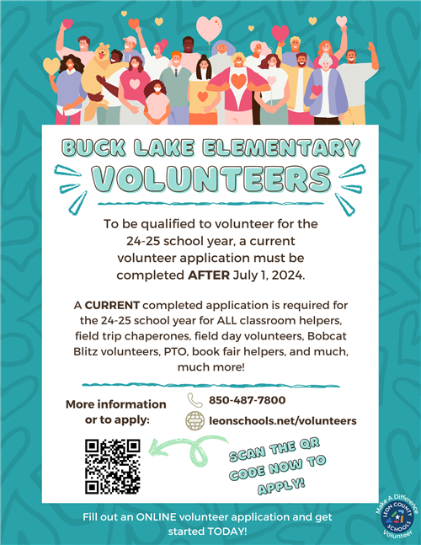

Please reach out to me if you happen to have any questions or concerns. I'm looking forward to a great year! 🙂

[Click here to visit my website!](https://www.leonschools.net/site/Default.aspx?PageID=11378)